|  |  |  |  |  |  |
| --- | --- | --- | --- | --- | --- |
| Date | 10-Dec-22 | | | Tester Name | Mohammad Yusuf |
| Environment | Penfax - Test | | | Login used |  |
| Operating System | Windows | Version: | Update: | | |
| Software Used | Edge | Version: | Update: | | |
| Not Applicable | Version: | Update: | | |
| Release version |  | | | | |
| Title | E7 Fund Transfers | | | | |
| Test Type | Regression | | | | |
| Test Scenario | E7.06 Change the Deposit Allocation Instructions | | | | |
|  |  | | | | |
| Expected Results | 1. Current Deposit Allocation should be changed immediately under Account Instruction in Penfax and should be displayed in Member PLANet. 2. Interfund Transfer should be processed and displayed under member’s account in Penfax and in Member PLANet. 3. PEPP Interfund Transfer Letter should be available. 4. Transcation should be listed on the Daily Valuation Report. | | | | |
| Pass/Fail | Pass | | | JIRA# | N/A |

Describe your steps with screenshots:

1. Go to Member Search -> Filter to Plan PEPP, Member Type Employee and Member Status to Active. Click on one of the Stakeholder IDs.

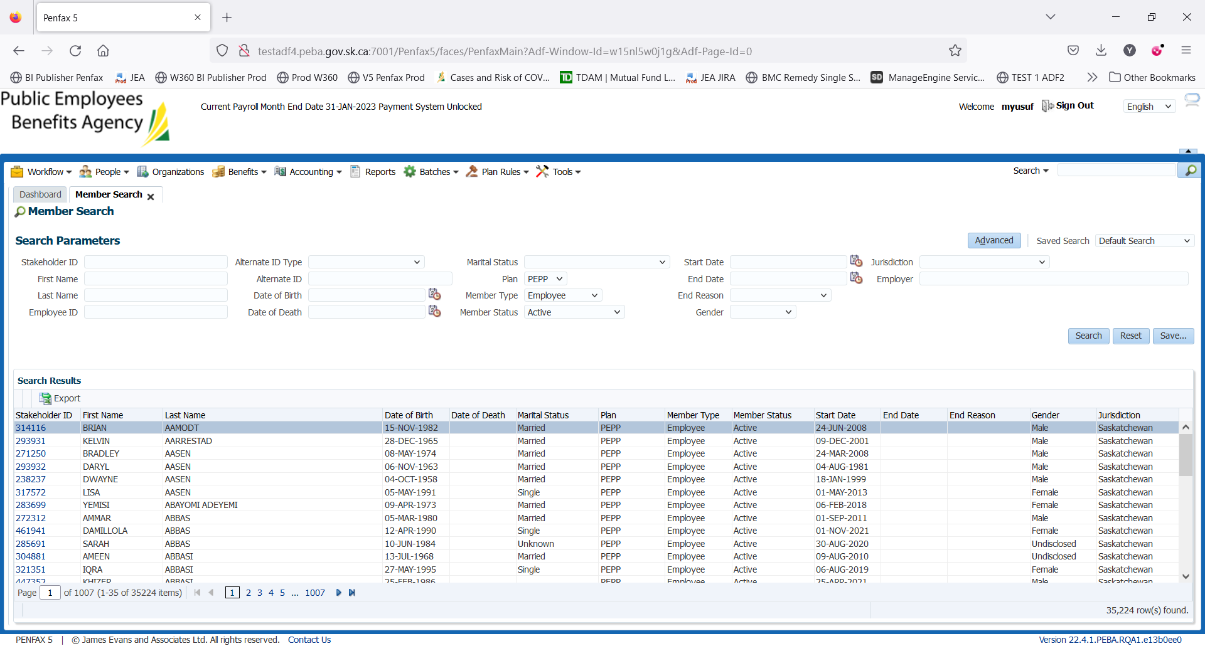

1. Click on Investments on the Navigation panel.

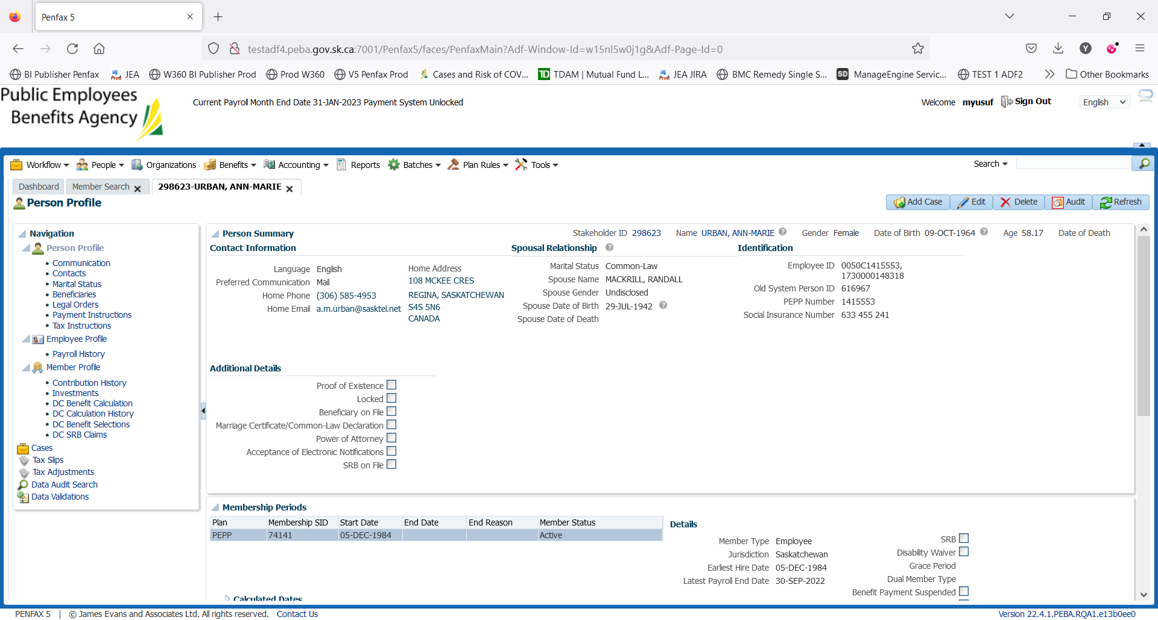

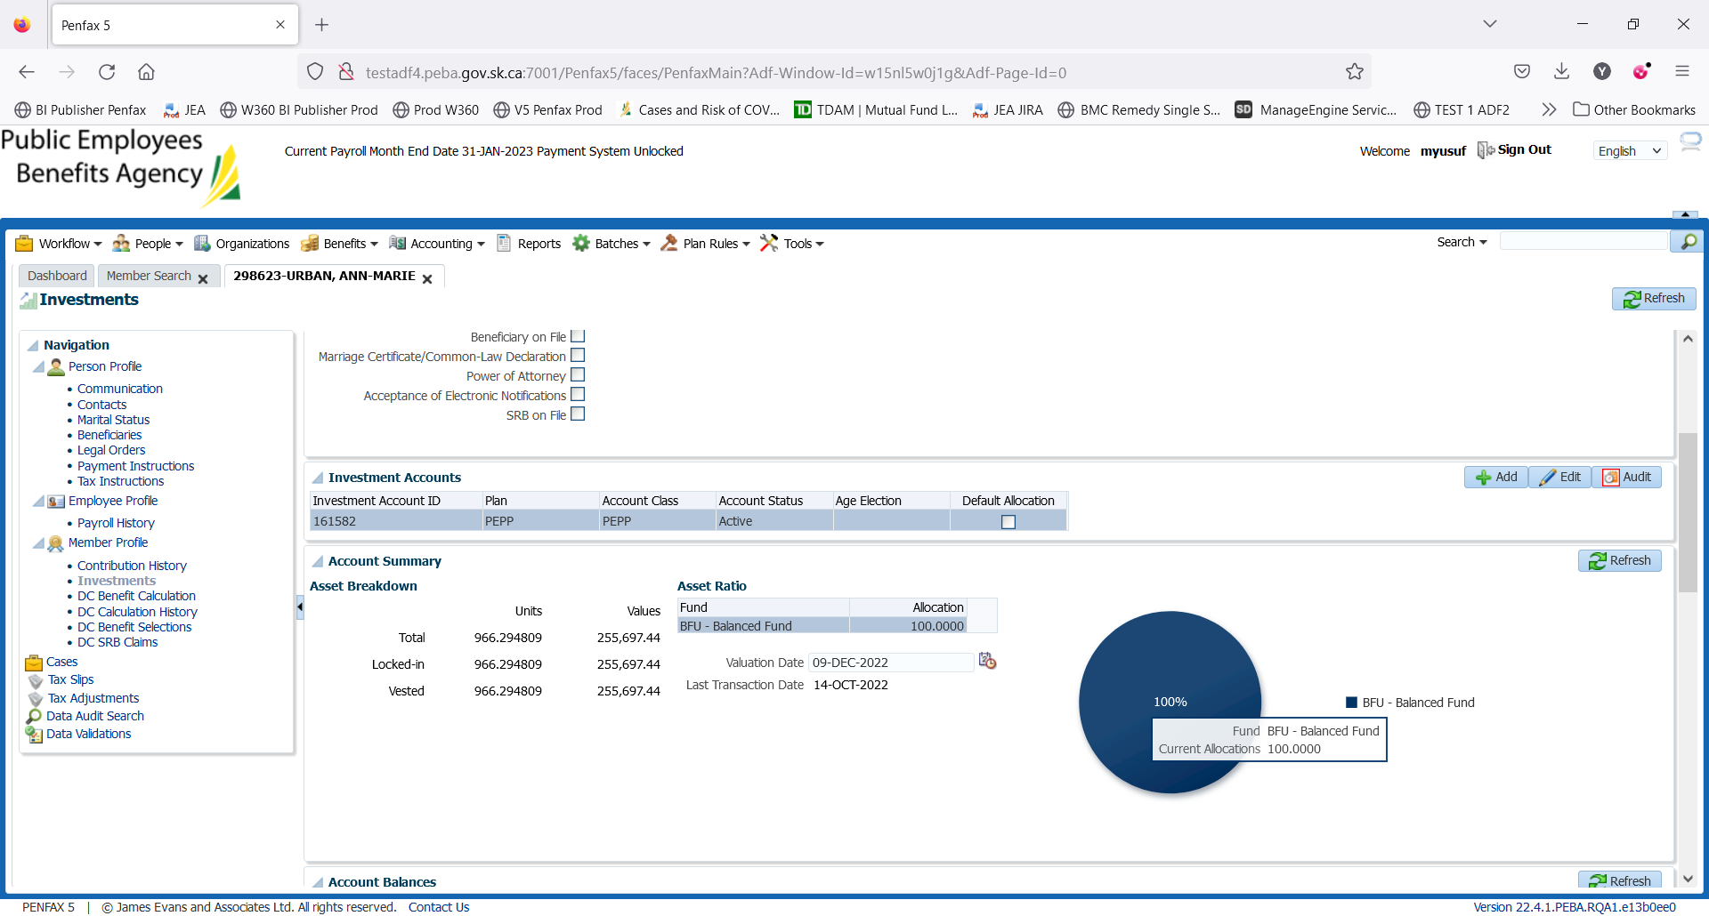

1. Scroll down and open up the Account Instructions Tab. Take note of what the current instructions are. Here, the current deposit allocation is 100% in BFU. Click Add.

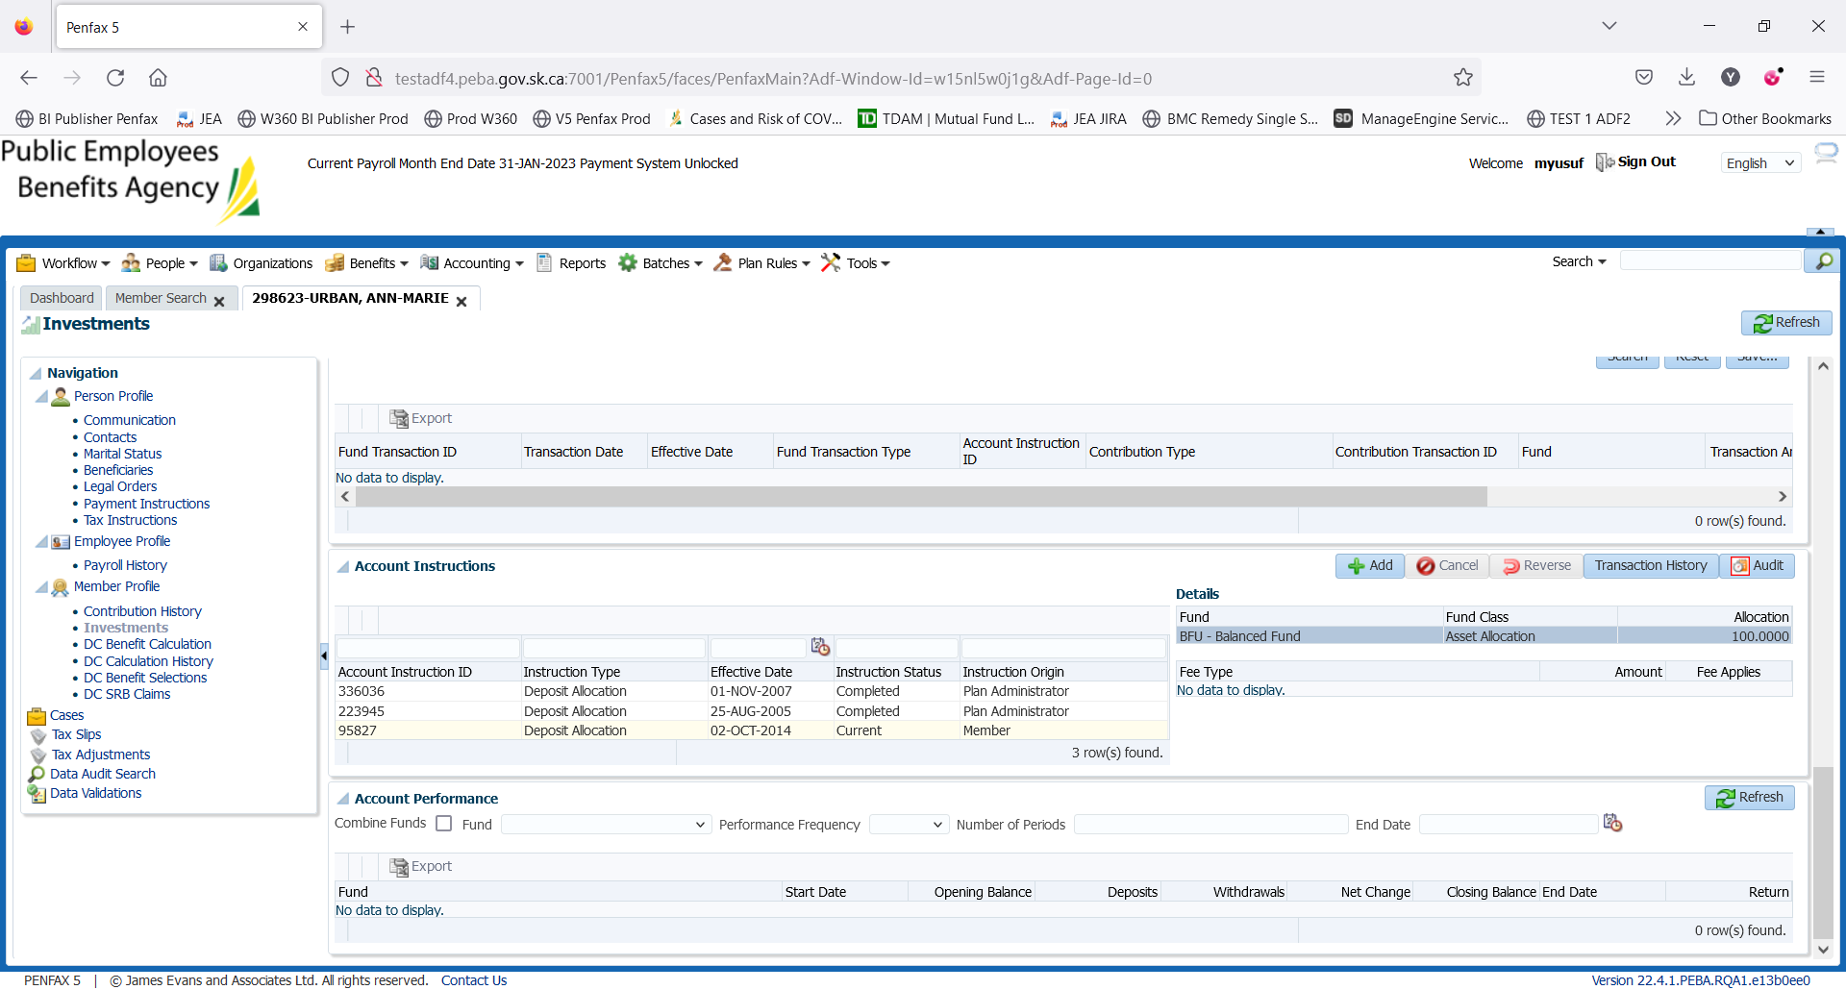

1. Under Instruction Type select Deposit Allocation.

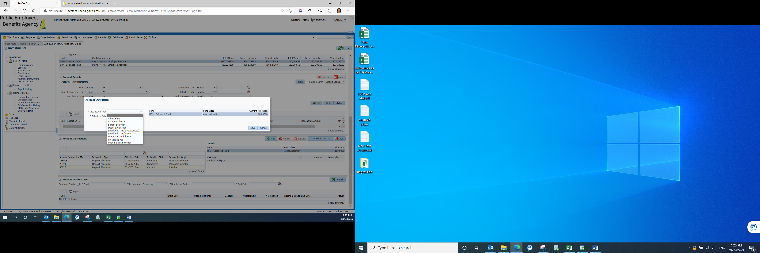

1. Click Add. Leave ‘Effective Date’ as it is. You can see where the current deposit allocation instruction on top right corner.

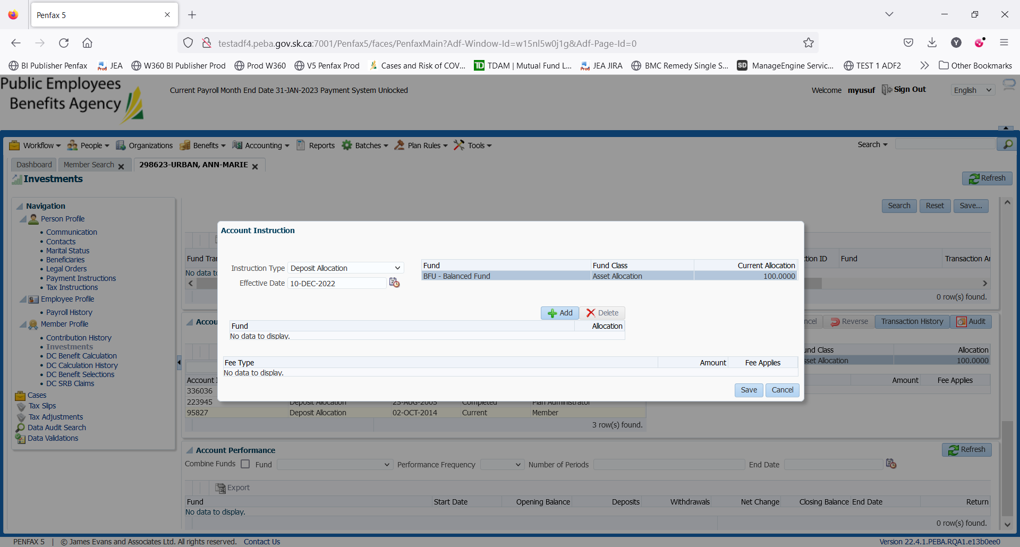

1. Select the funds to which you want to change the deposit allocation and input percentage of allocation and click Save.

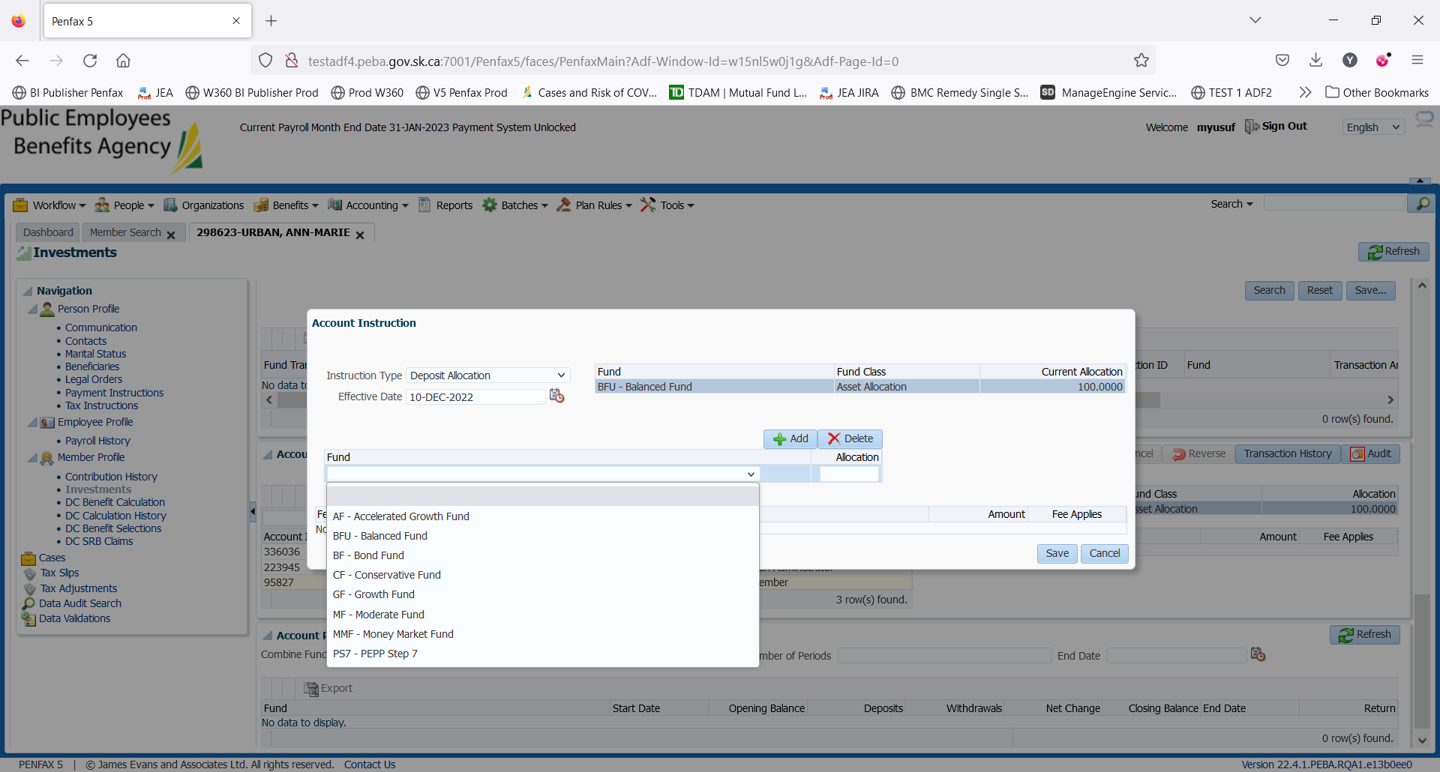

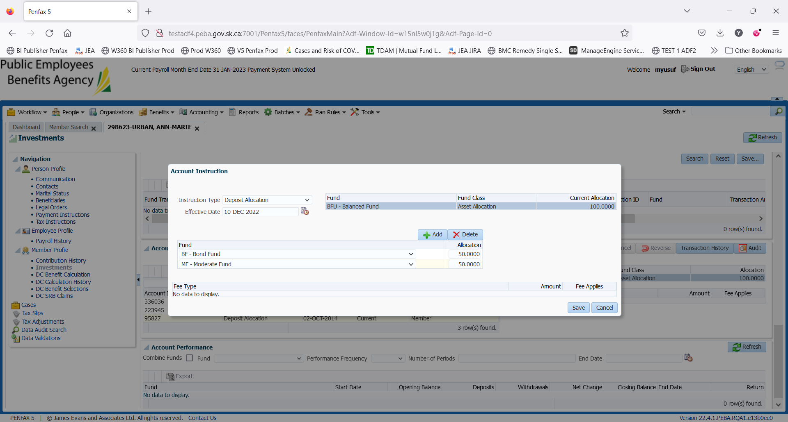

1. Validation warning is triggered on this stage. Click ‘Accept and Continue’ and the new Deposit Allocation instruction can be seen with the Current status.

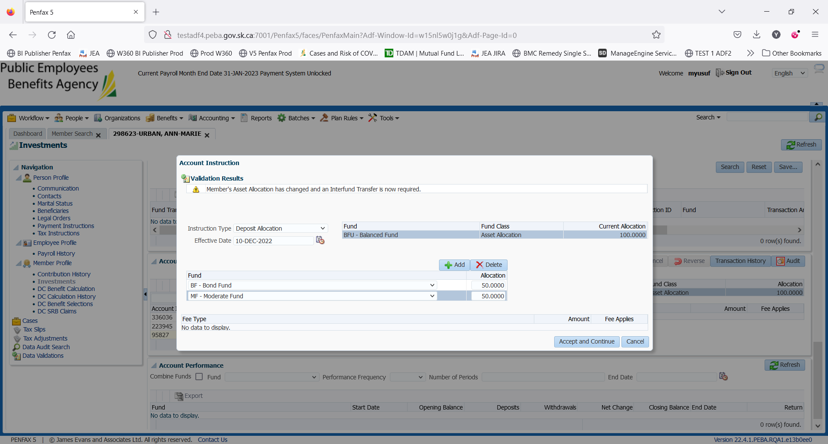

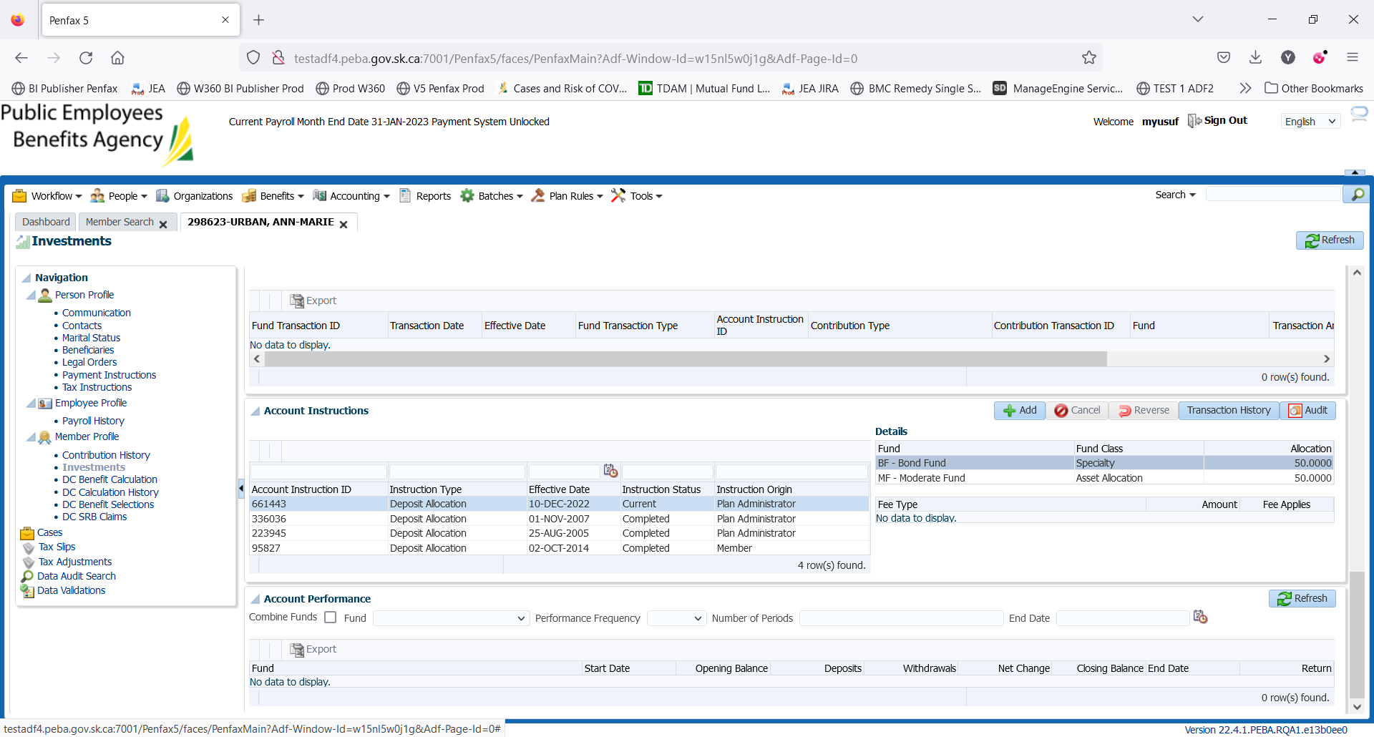

1. Perform Interfund Transfer right after changing Deposit Allocation. Select Interfund Transfer (Basic) as Instruction Type. Leave Effective Date and Fee Applies as they are. Click Add and select funds to which your money will be transferred and input the allocation percentage. Click Save.

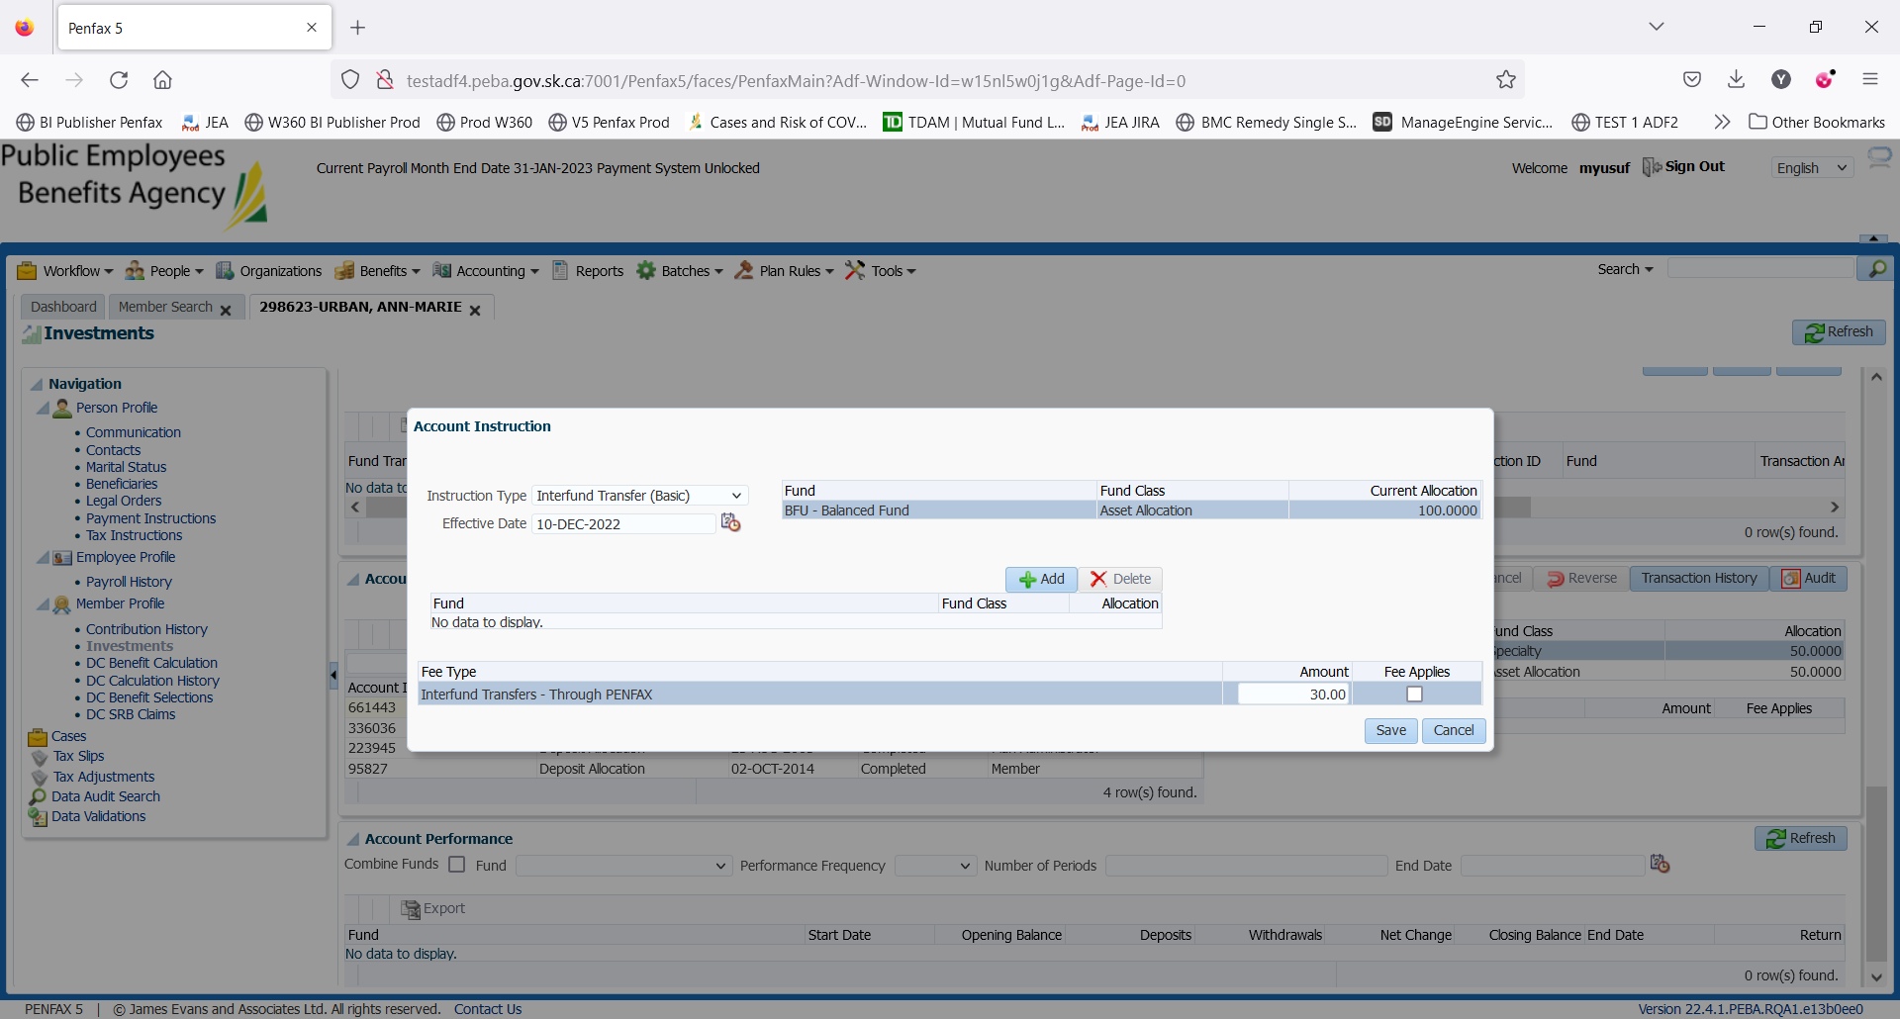

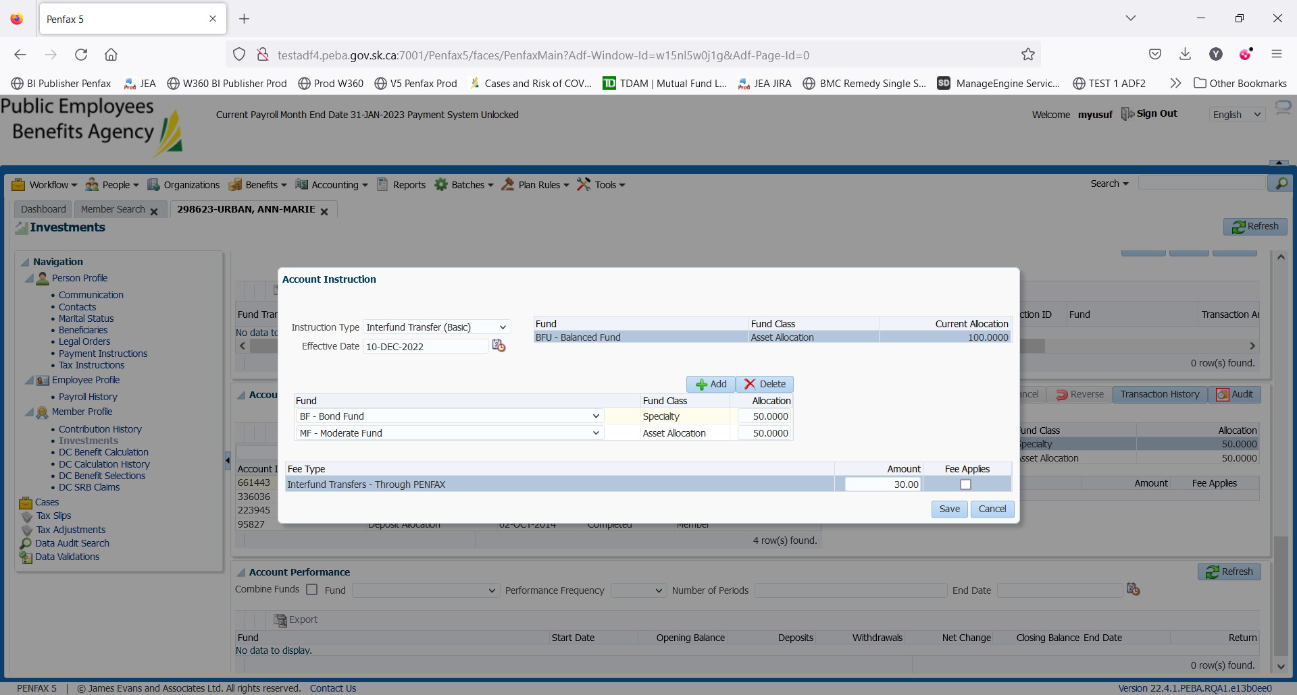

1. A new instruction type can be seen under Account Instruction with pending status.

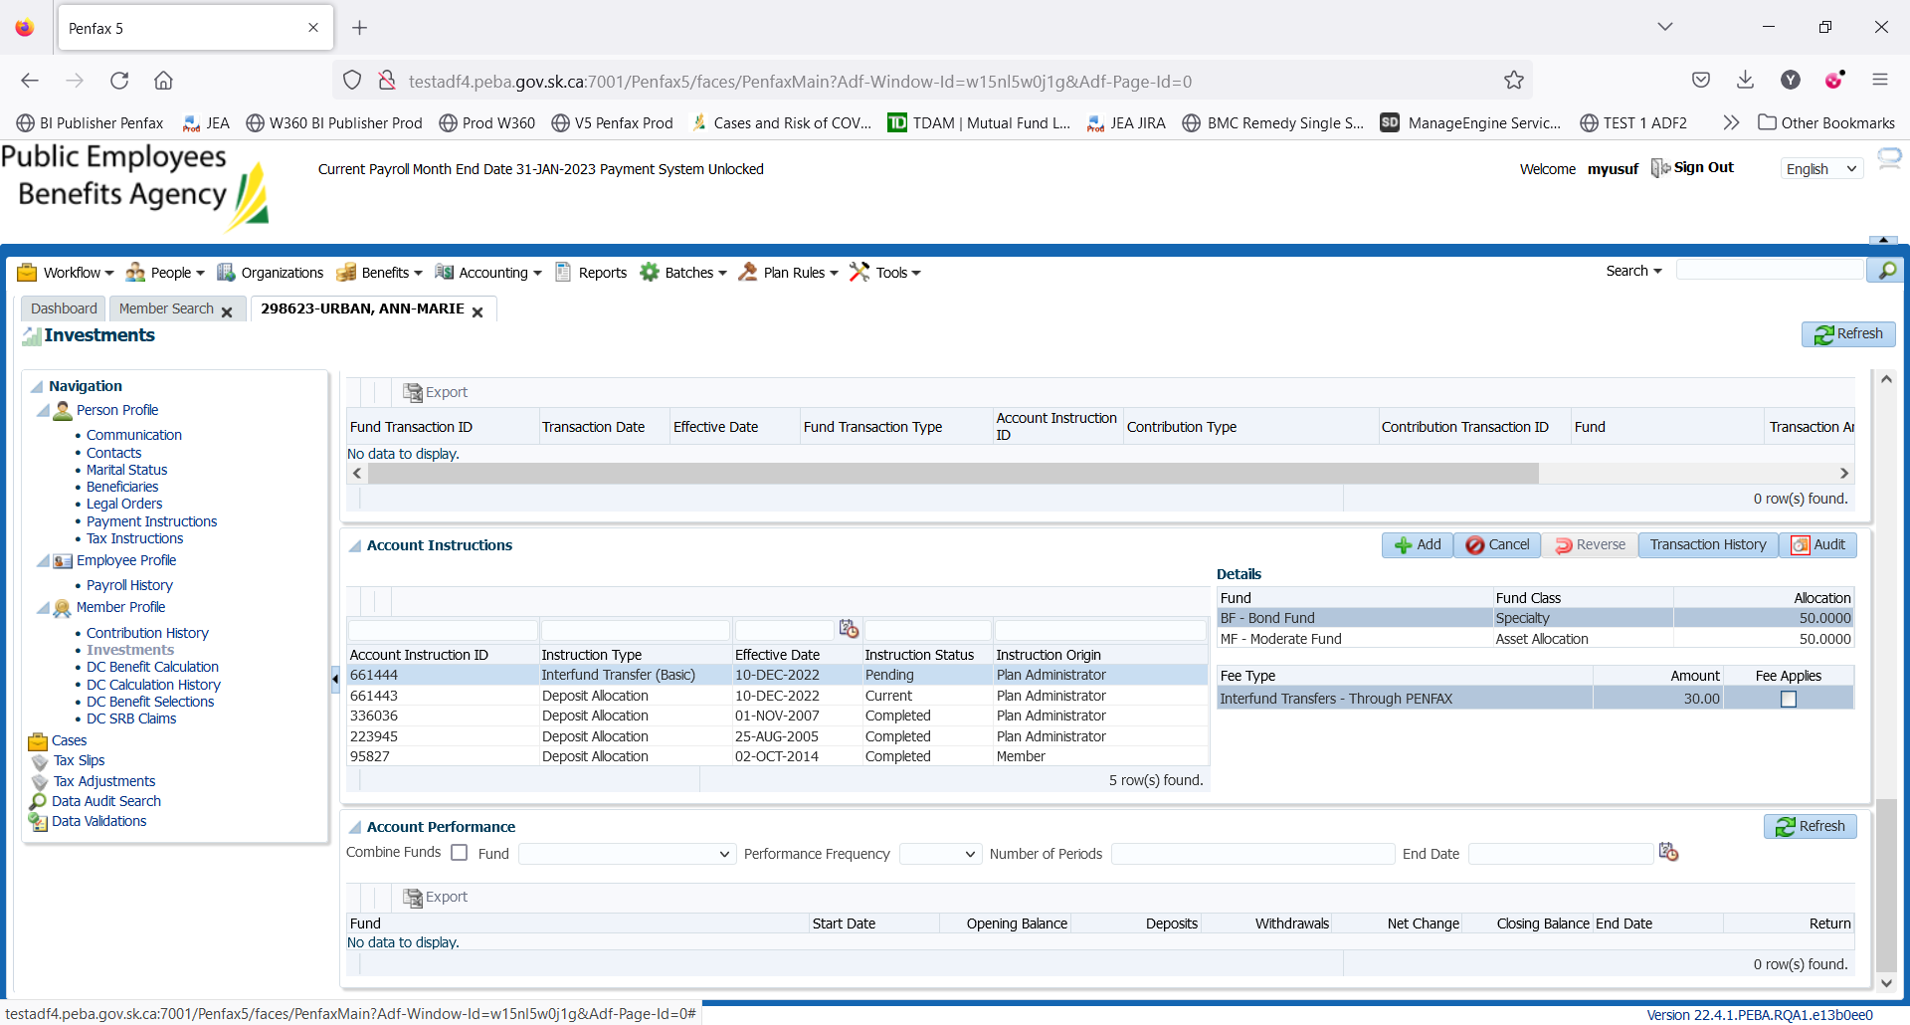

1. Member can see this pending Interfund Transfer in Member PLAnet (PENWEB).

This interfund transfer was done on sept 19, 2022 after 2:00 PM and so this will be processed and available in Penfax and Penweb a day after i.e. Sept 19, 2022.

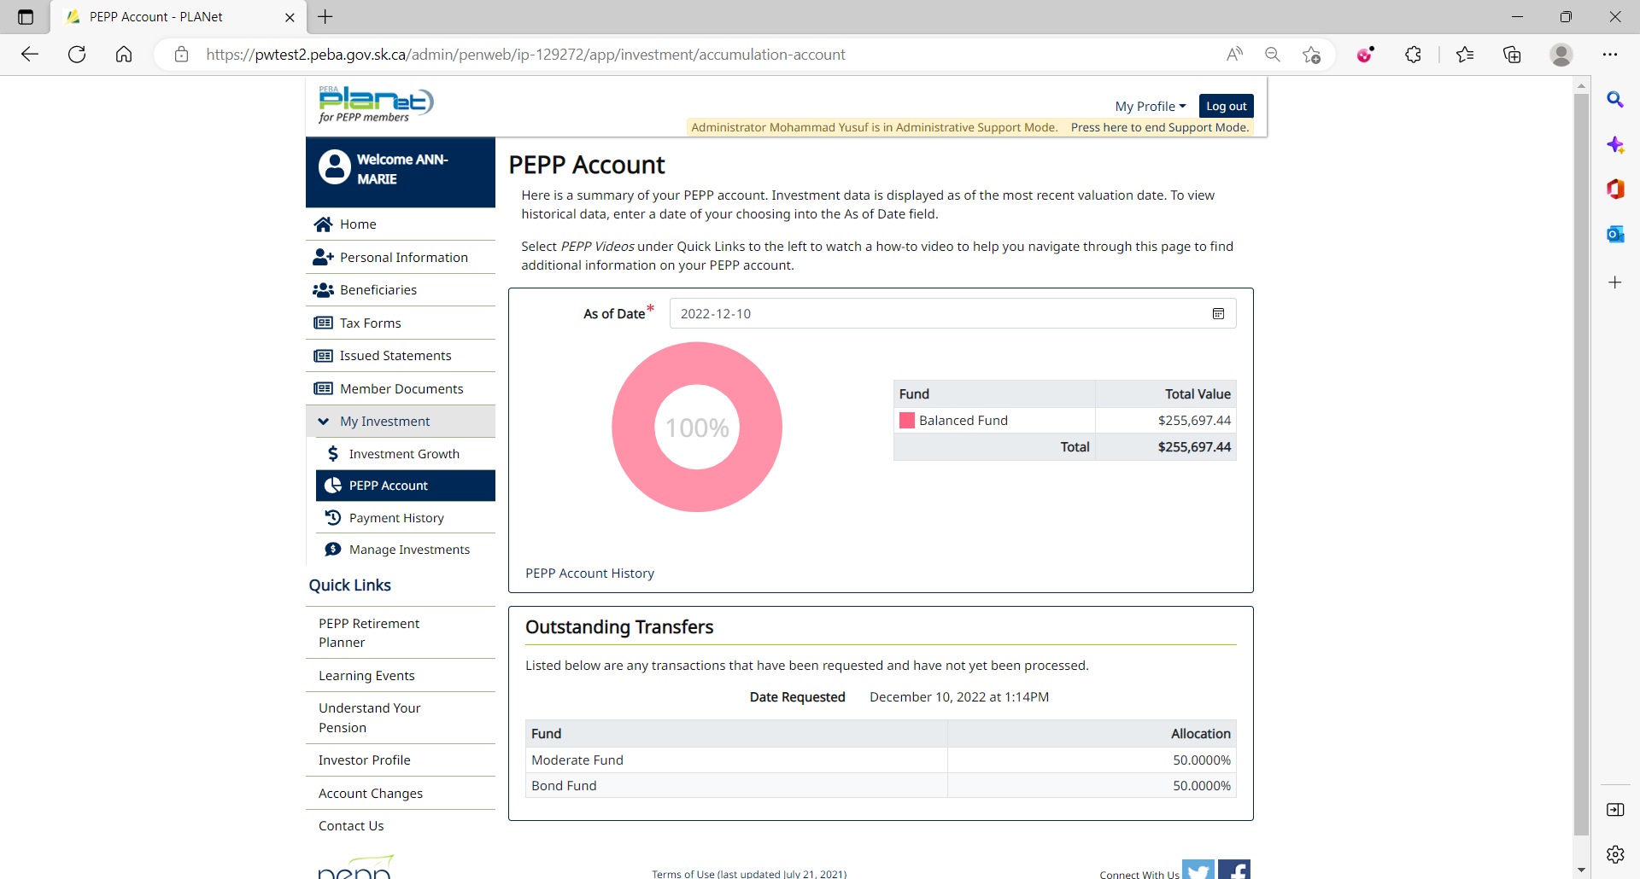

1. PIT batch was run overnight.
2. As per the Interfund Transfer processed yesterday (Sept 19, 2022), funds have been transferred 50% to PS7 and 50% to MMF.

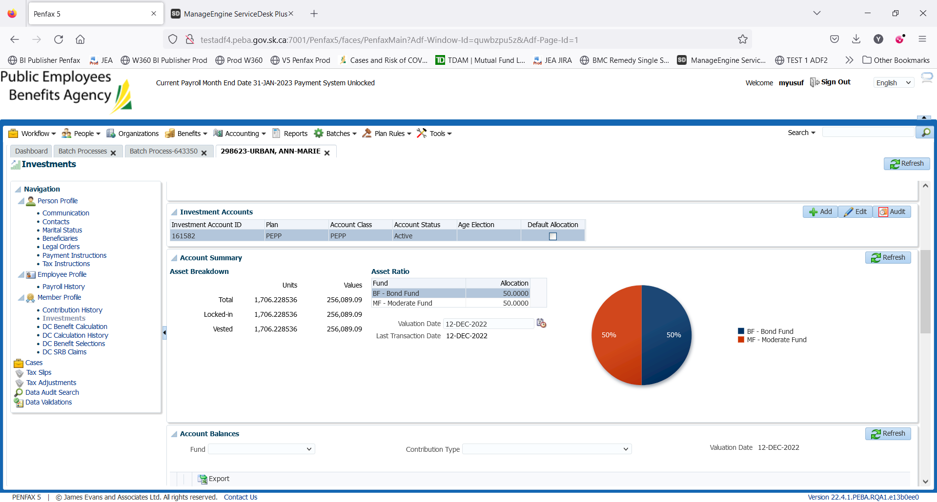

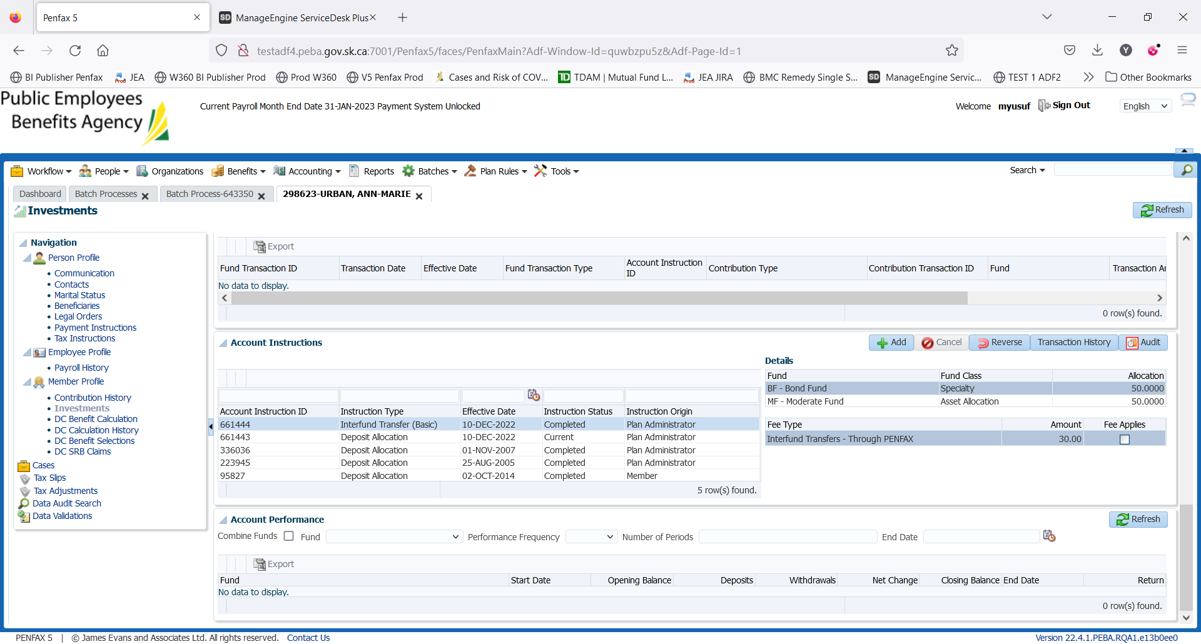

Transaction History of Interfund Transfer

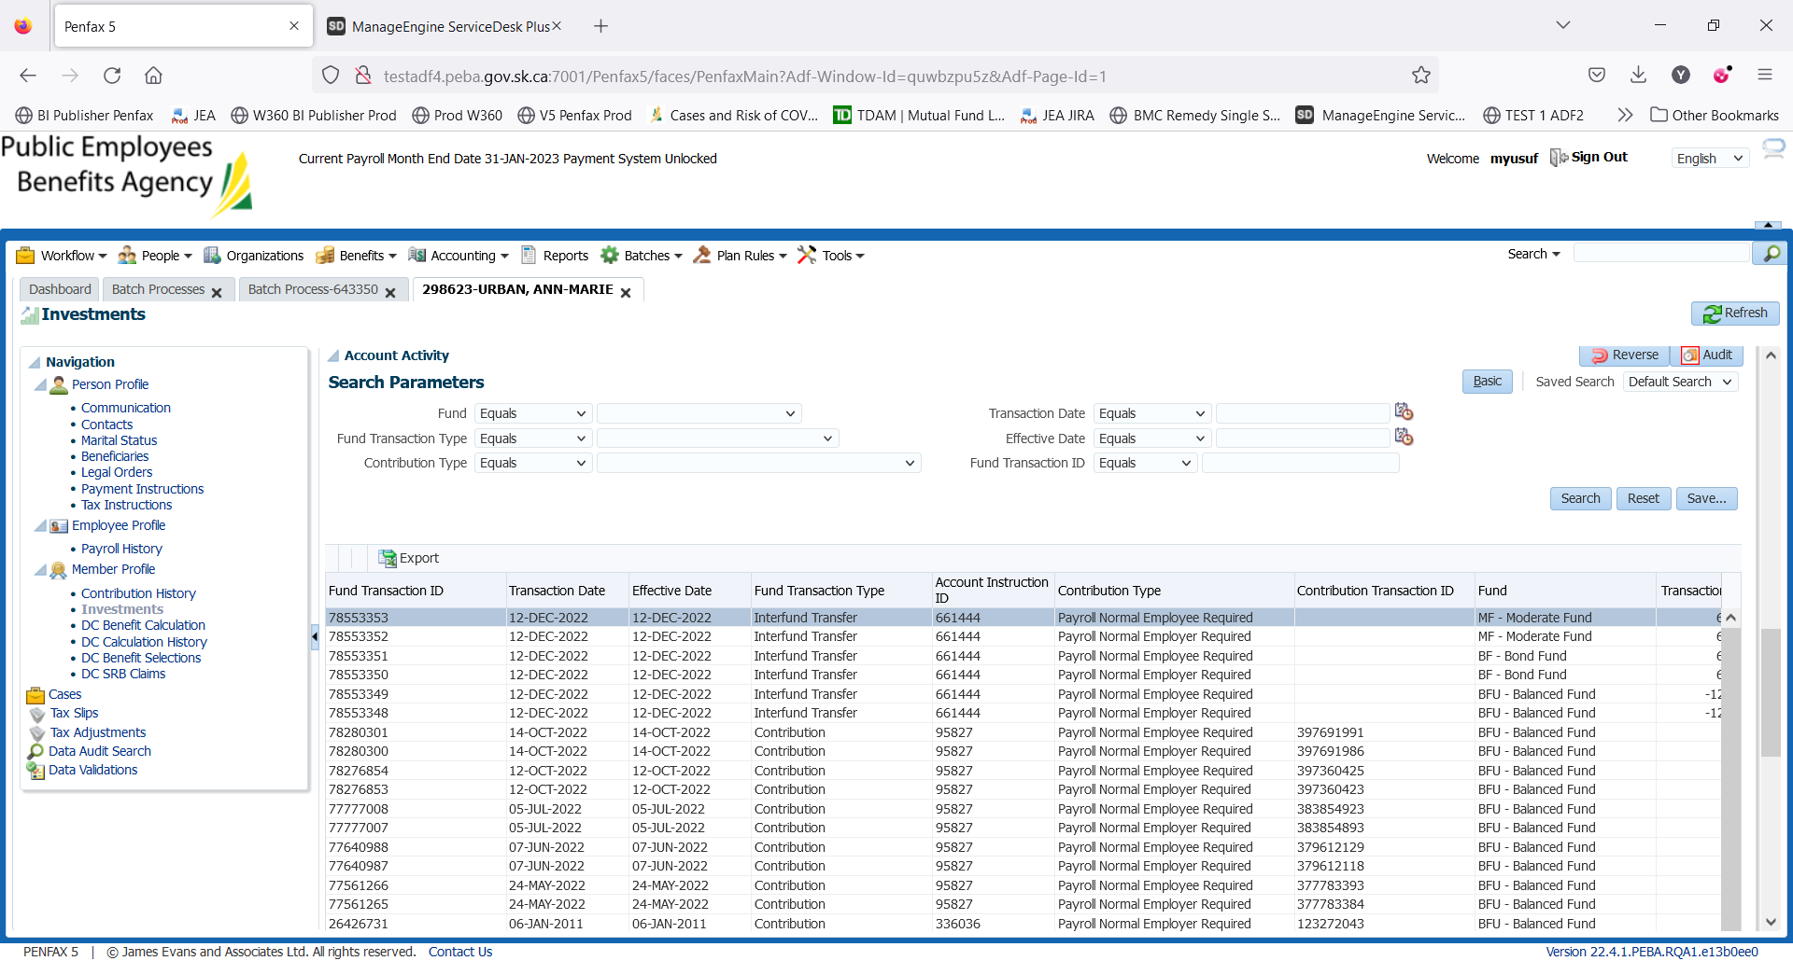

1. PEPP Interfund Transfer letter is available under Person Profile -> Communication -> Outbound Documents.

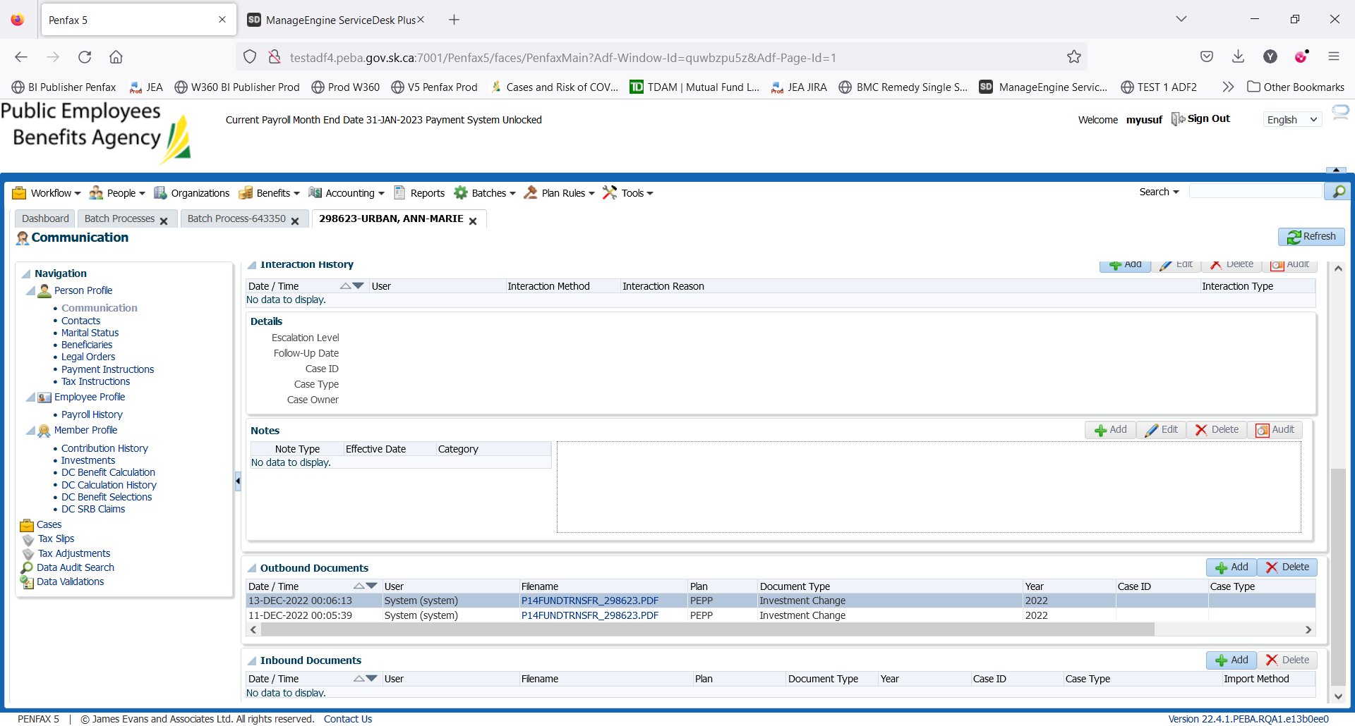

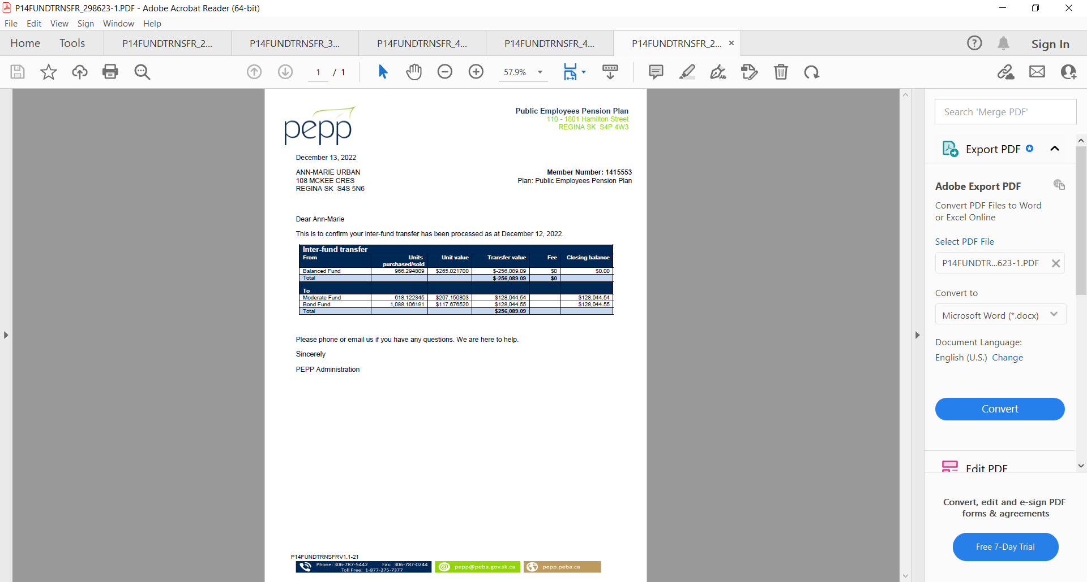

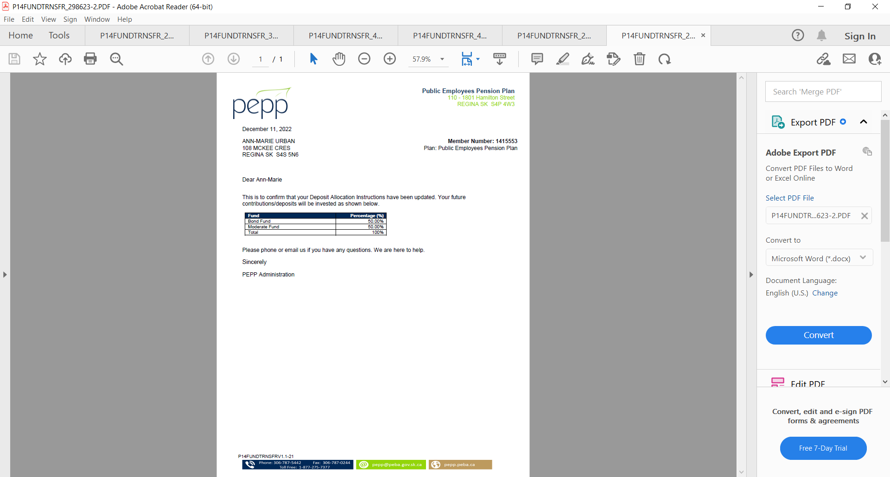

1. Check the Valuation Report. Go to Batches -> Batch Processes. Search with “PEPP Valuation Report” as Batch Process Type and open the very first record in the list (batch processed a day before).

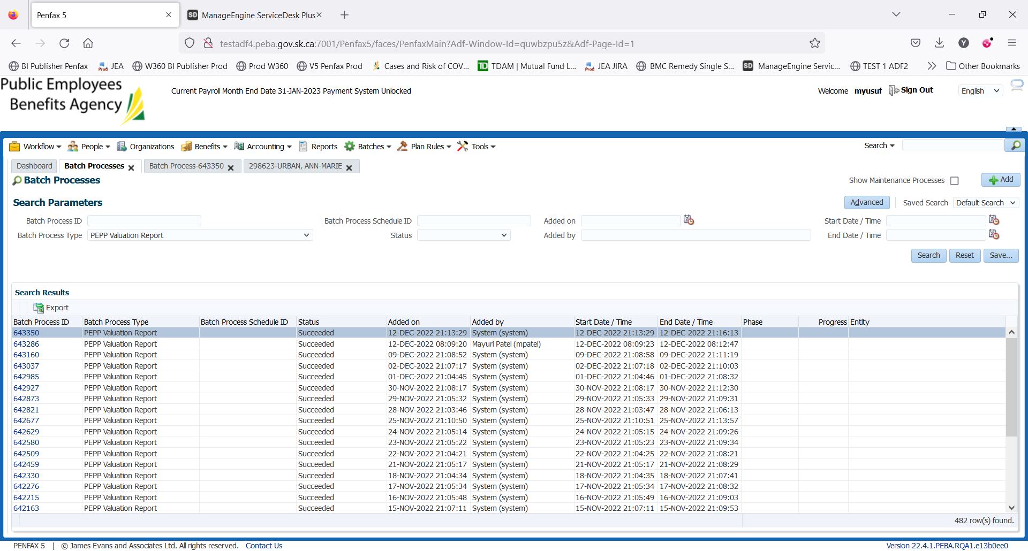

Go to Files tab and open PEPP valuation excel.

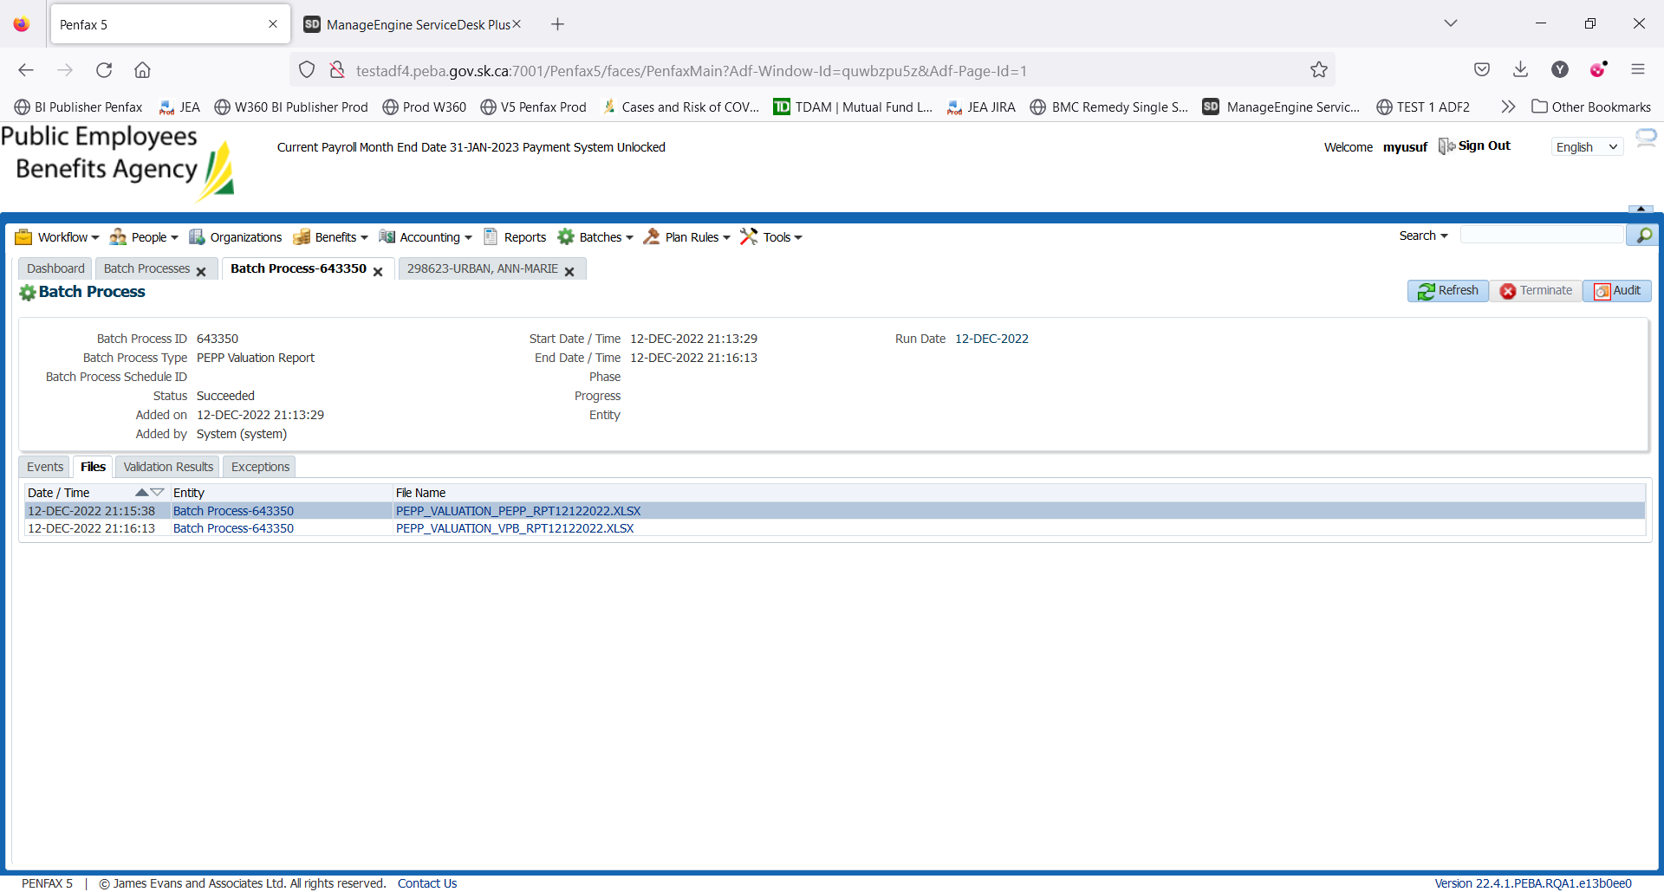

Section Four (Transfer In)

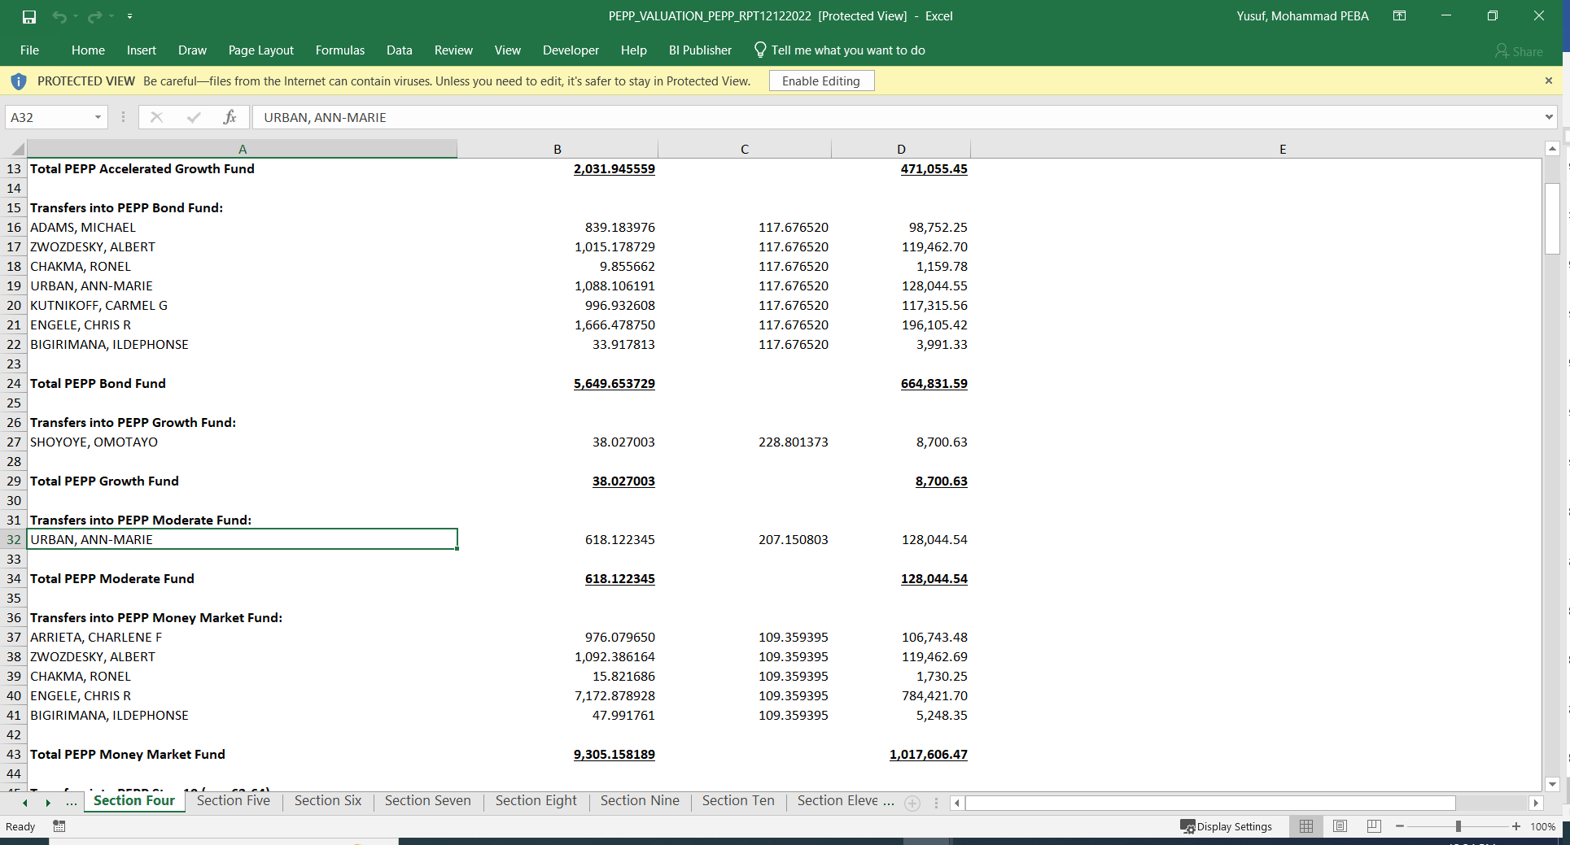

Section Nine (Transfer Out)

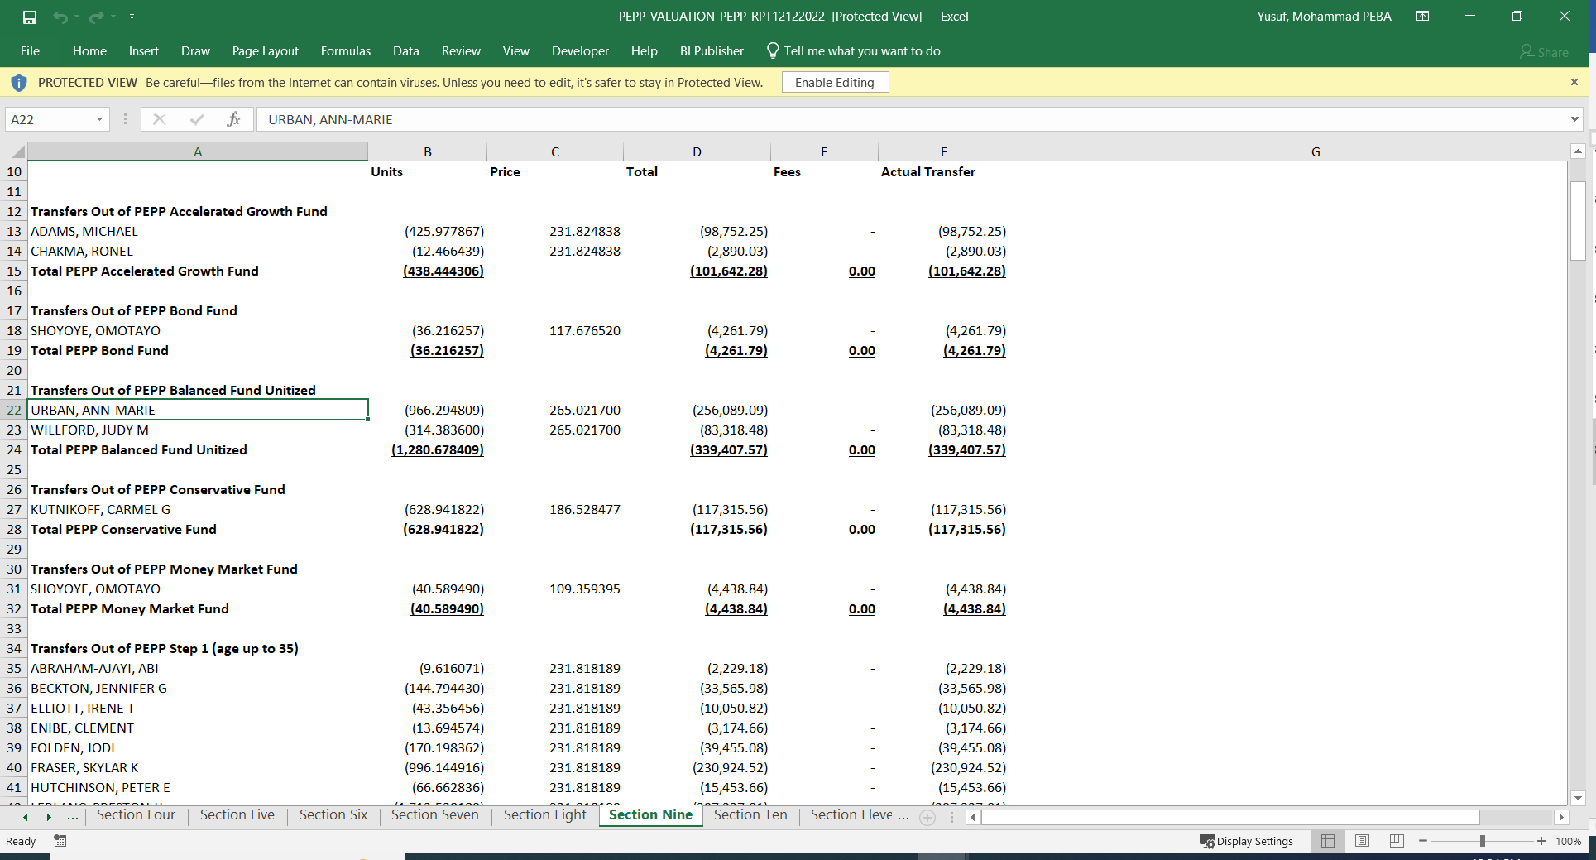

1. Member PLANet -> My Investment -> PEPP Account

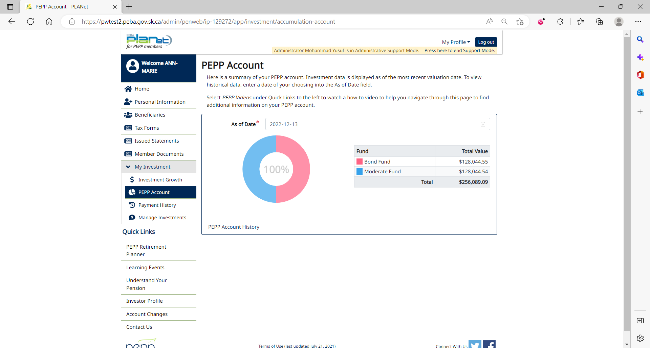

1. Member PLANet -> My Investment -> Manage Investments -> Current DAI

